**SQLlite syntax**

**Tbl_Project table:**

Firstly, I will create the project table using the CREATE TABLE (); function.

**Create Table Syntax:**

CREATE TABLE Tbl_Project (

CHG_HOUR TEXT NOT NULL,

PROJ_NO INTEGER PRIMARY KEY AUTOINCREMENT NOT NULL,

EMP_NUM INTEGER NOT NULL,

HOURS NUMERIC NOT NULL,

PROJ_NAME TEXT NOT NULL,

PROJ_STARTDATE TEXT NOT NULL,

PROJ_ENDDATE TEXT NOT NULL,

FOREIGN KEY (EMP_NUM) REFERENCES Tbl_Employee (EMP_NUM) ON DELETE CASCADE ON UPDATE CASCADE

);

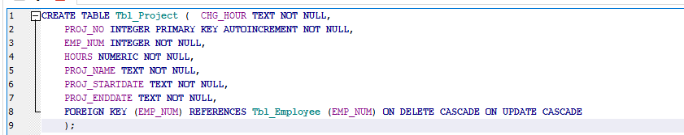

**Insert Values Syntax:**

INSERT INTO Tbl_Project (PROJ_NO, EMP_NUM, HOURS, PROJ_NAME, PROJ_STARTDATE, PROJ_ENDDATE)

VALUES

('15', '103', '23.8', 'Evergreen' , '3/15/2024', '6/30/2024'),

('15', '101', '19.4', 'Amber Wave' , '5/1/2024', '8/15/2024'),

('15', '105', '35.7', 'Rolling Tide' , '7/10/2024', '10/25/2024'),

('15', '106', '12.6', 'Starflight' , '9/5/2024', '12/20/2024'),

('15', '102', '23.8', 'Evergreen' , '1/15/2024', '2/20/2024'),

('18', '114', '24.6', 'Amber Wave' , '2/2/2024', '3/23/2024'),

('18', '118', '45.3', 'Rolling Tide' , '3/10/2024', '4/30/2024'),

('18', '104', '30.5', 'Starflight' , '4/22/2024', '6/10/2024'),

('18', '112', '44', 'Evergreen' , '5/5/2024', '7/15/2024'),

('22', '105', '64.7', 'Amber Wave' , '6/18/2024', '8/28/2024'),

('22', '104', '48.4', 'Rolling Tide' , '7/1/2024', '9/15/2024'),

('22', '113', '23.6', 'Starflight' , '8/8/2024', '10/22/2024'),

('22', '111', '22', 'Evergreen' , '9/19/2024', '11/30/2024'),

('22', '106', '12.8', 'Amber Wave' , '10/24/2024', '1/15/2025'),

('25', '107', '24.6', 'Rolling Tide' , '11/11/2024', '2/28/2025'),

('25', '115', '45.8', 'Starflight' , '12/3/2024', '3/18/2025'),

('25', '101', '56.3', 'Evergreen' , '1/7/2024', '2/12/2025'),

('25', '114', '33.1', 'Amber Wave' , '2/14/2024', '3/31/2025'),

('25', '108', '23.6', 'Rolling Tide' , '3/21/2024', '5/10/2025'),

('25', '118', '30.5', 'Starflight' , '4/28/2024', '6/15/2025'),

('25', '112', '40', 'Evergreen' , '5/30/2024', '7/20/2025');

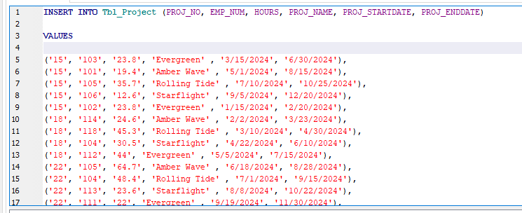

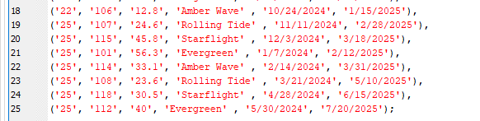

Tbl_Job Table:

I will then create the Job table using the CREATE TABLE (); function.

**Create Table Syntax:**

CREATE TABLE Tbl_Job

(

JOB_CLASS TEXT NOT NULL,

CHG_HOUR TEXT NOT NULL,

PRIMARY KEY (JOB_CLASS)

);

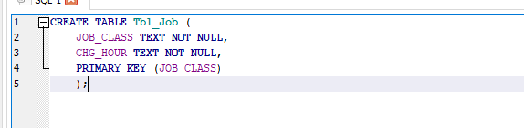

**Insert Values Syntax:**

INSERT INTO Tbl_Job( JOB_CLASS, CHG_HOUR)

VALUES

('Elect. Engineer', '£84.50'),

('Programmer', '£35.75'),

('Systems Analyst', '£96.75'),

('General Support', '£18.36'),

('DSS Analyst', '£45.95'),

('Database Designer ', '£105.00' ),

('Applications Designer', '£48.10'),

('Clerical Support', '£26.87');

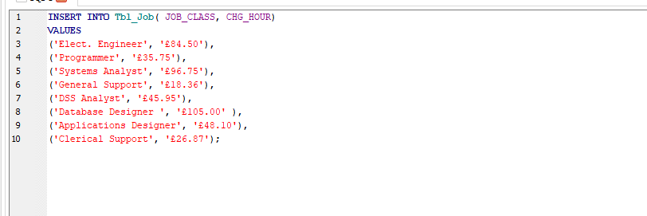

**Trailing spaces error:**

However, I ran into a problem when creating the Tbl_Employee <-- entity.: 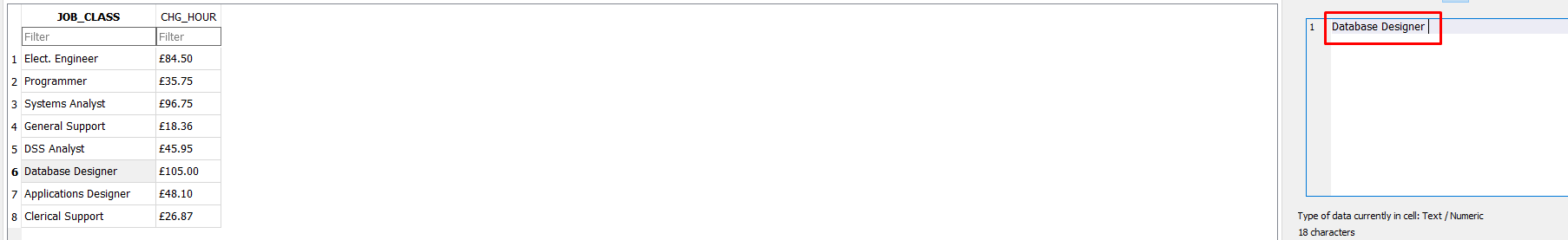

We can see that I accidentally put a space after ‘Database Designer’. This is bad as I will encounter the error:



I am getting this error because I have trailing spaces. To fix this. I will update ‘Database Designer’ to ensure there are no trailing spaces.

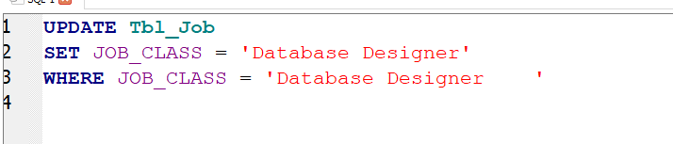

I then tried to input the same data into Tbl_Employee, ending up with a successful execution.



**Tbl_Employee table:**

Next would be to create the Employee table using the CREATE TABLE (); function.

CREATE TABLE Tbl_Employee

(

EMP_NUM INTEGER NOT NULL,

EMP_FNAME TEXT NOT NULL,

EMP_MNAME TEXT,

EMP_LNAME TEXT NOT NULL,

JOB_CLASS TEXT NOT NULL,

EMP_SKILL_LEVEL TEXT NOT NULL,

PRIMARY KEY (EMP_NUM)

FOREIGN KEY (JOB_CLASS) REFERENCES Tbl_Job(JOB_CLASS) ON DELETE CASCADE ON UPDATE CASCADE

);

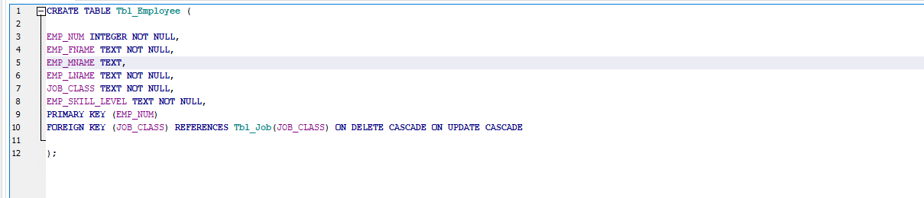

**Insert Values Syntax:**

INSERT INTO Tbl_Employee (EMP_NUM, EMP_FNAME, EMP_MNAME, EMP_LNAME, JOB_CLASS , EMP_SKILL_LEVEL)

VALUES

('103', 'June', 'E.', 'Arbough', 'Elect. Engineer' , 'Advanced'),

('101', 'John', 'G.', 'News ', 'Database Designer' , 'Intermediate'),

('106', 'William', '', 'Smithfield', 'Programmer' , 'Advanced'),

('102', 'David', 'H.', 'Senior', 'Systems Analyst' , 'Intermediate'),

('114', 'Annelise', '', 'Jones', 'Applications Designer' , 'Beginner'),

('118', 'James', 'J.', 'Frommer', 'General Support' , 'Intermediate'),

('104', 'Anne', 'K.', 'Ramoras', 'Systems Analyst' , 'Advanced'),

('112', 'Darlene', 'M.', 'Smithson', 'DSS Analyst' , 'Beginner'),

('105', 'Alice', 'K.', 'Johnson', 'Database Designer' , 'Advanced'),

('113', 'Delbert', 'K.', 'Joenbrood', 'Applications Designer' , 'Intermediate'),

('111', 'Geoff', 'B.', 'Wabash', 'Clerical Support' , 'Beginner'),

('107', 'Maria', 'D.', 'Alonzo', 'Programmer' , 'Intermediate'),

('115', 'Travis', 'B.', 'Bawangi', 'Systems Analyst' , 'Beginner'),

('108', 'Ralph', 'B.', 'Washington', 'Systems Analyst' , 'Advanced');

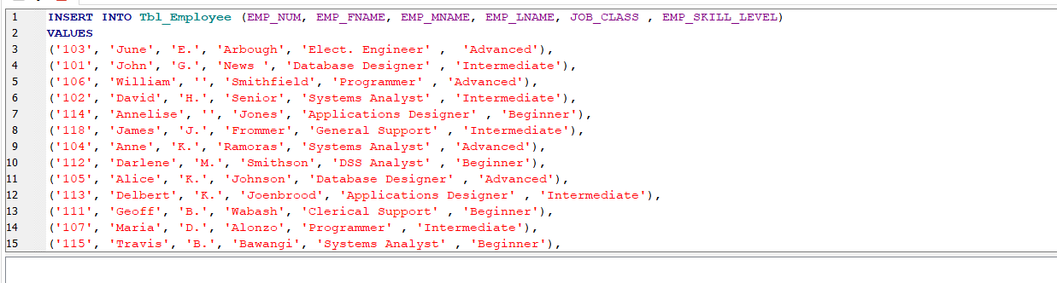

**Tbl_EmployeeContact table:**

Finally, I used the CREATE TABLE (); function to create the EmployeeContact entity.

**Create Table Syntax:**

CREATE TABLE Tbl_EmployeeContact

(

CONTACT_ID INTEGER NOT NULL PRIMARY KEY AUTOINCREMENT,

EMP_EMAIL TEXT NOT NULL,

EMP_PHONE INT NOT NULL,

EMP_ADDRESS TEXT NOT NULL,

EMP_POSTCODE TEXT NOT NULL

);  
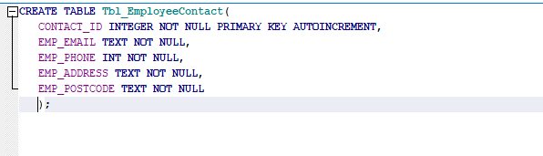

**Insert Values Syntax:**

INSERT INTO Tbl_EmployeeContact (CONTACT_ID, EMP_EMAIL, EMP_PHONE,EMP_ADDRESS, EMP_POSTCODE)

VALUES

('1', 'JuneAR@gmail.com', '07123 456789' , '122 Main Street, London', 'SW1A 1AA'),

('2', 'JohnNE@gmail.com', '07234 567890' , '456 Oak Avenue, Manchester', 'M2 2AB'),

('3', 'WilliamSM@gmail.com', '07345 678901' , '789 Pine Close, Birmingham', 'B1 1BC'),

('4', 'DavidSE@gmail.com', '07456 789012' , '101 Maple Drive, Edinburgh', 'EH1 2CD'),

('5', 'AnneliseJO@gmail.com', '07567 890123' , '202 Elm Lane, Cardiff', 'CF1 3DE'),

('6', 'JamesFR@gmail.com', '07678 901234' , '303 Birch Road, Belfast', 'BT1 4EF'),

('7', 'AnneRA@gmail.com', '07789 012345' , '404 Cedar Court, Liverpool', 'G1 5FG'),

('8', 'DarleneSM@gmail.com', '07890 123456' , '555 Willow Street, Liverpool', 'L1 6GH'),

('9', 'AliceJO@gmail.com', '07901 234567' , '606 Pine Lane, Bristol', 'BS1 7HI'),

('10', 'DelbertJO@gmail.com', '07912 345678' , '707 Oak Square, Newcastle', 'NE1 8IJ'),

('11', 'GeoffWA@gmail.com', '07923 456789' , '808 Birch Terrace, Leeds', 'LS1 9JK'),

('12', 'MariaAL@gmail.com', '07934 567890' , '909 Maple Place, Nottingham', 'NG1 10KL'),

('13', 'TravisBA@gmail.com', '07945 678901' , '1212 Elm Gardens, Sheffield', 'S1 11LM'),

('14', 'RalphWA@gmail.com', '07956 789012' , '1313 Cedar Avenue, Southampton', 'SO1 12MN');

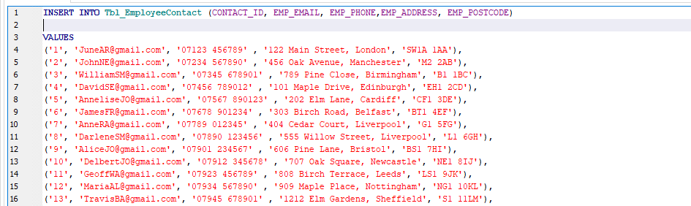



Reference: W3Schools.   
https://www.w3schools.com/sql/sql_select.asp